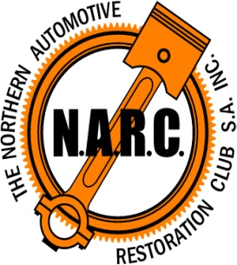

CLARE VALLEY CRUISE for CANCER
Saturday, 18th March, 2023
Commencement time 2.00pm from Mintaro Oval.
Concludes at Pikes Winery approx 4.00pm
Entry Fee $10.00 per vehicle. Proceeds to the Cancer Council.

Complete the details below and pay by direct debit. BSB 015-552, A/c 414239425 or send your cheque payable to: NARC S.A. INC. to Ann Hammat, 262 Mayfield Road, Washpool SA 5454

Name:_______________________________________________________________

Address:_____________________________________________________________

Phone:______________________________________________________________

Vehicle Make: ___________________________________Year:_________________

Registration No: _______________________________________________________

Please nominate for either long course (suitable for classic cars) □
or short course (suitable for older vehicles) □

Indemnity Declaration

In consideration of this entry, I/We agree that the promoting committee and its associated organisation (NARC) will in no way be held responsible for the loss or damage to a participating Vehicle, its Parts or accessories and personal effects, or of any damage caused by such Vehicle or any Participant by entering, driving, or being a passenger in this event.
I/We thereby waive the right or action at law against the committee, its organisers, their representatives and Agents.

All Vehicles will be roadworthy, appropriately registered and drivers must be the holder of a current Driver’s Licence for the class of vehicle being driven, and must abide by all road and traffic laws.

Signed by the entrant __________________________________________________________

Date __________/____/2023

Please send completed entry form to ann@baderloo.com.au or post to Ann Hammat, 262 Mayfield Road, Washpool, SA 5454

