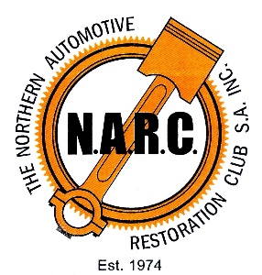
The Northern Automotive Restoration Club SA Inc

A Weekend of Memorable Motoring

Event Director: Trev Naismith Phone: 0409 648 424
Event Secretary: Ann Hammat Phone :0408 654 019

Dear Motoring Enthusiast

The Northern Automotive Restoration Club SA wish to extend an invitation for you to participate in our Weekend of Memorable Motoring to be held in the Clare Valley over the weekend of March 18 and 19, 2023.

The weekend will be made up of two events. On Saturday March 18, the Cruise for Cancer will commence at the Mintaro Oval at 2:00 pm and takes in some of the lesser known bitumen backroads of the beautiful Clare and Gilbert Valleys. This year, the Cruise will have a long course and a short course which reflects the diverse mix of cars that will be in the Cruise. The long course (100kms) is best suited for those classic and contemporary cars that have good road speed and the short course (50kms) is more suitable for older cars that travel at a more moderate pace. Note that all proceeds from the Cruise are donated to the Cancer Council.

The Cruise will again conclude at the Pikes Winery and Brewery at Hill River at 4:00pm where there will be food and refreshments available for purchase.

That evening, you are free to enjoy many of the restaurants, cafes and hotels that are dotted throughout the Clare Valley, including the award winning Slate Restaurant at Pikes.

On Sunday March 19, the Clare Valley Show and Shine will open to the public at 10:00am with a range of categories to suit your car. Along with the Cruise for Cancer, the Show and Shine is a great opportunity for you to display your car and share your enthusiasm with like minded individuals and the general public.

There will be affordable food and coffee outlets at the oval along with a pub and restaurant within walking distance.

Entry forms are attached which cover admittance for the driver and passenger. Please complete and lodge the entry form and payment by EFT or cheque. Please clearly state your family and given names on the EFT. Car numbers will be issued on the day and you will be directed to staging locations on the oval.

I look forward to seeing you in the beautiful Clare Valley for a Weekend of Memorable Motoring!

Trev Naismith
Event Director

