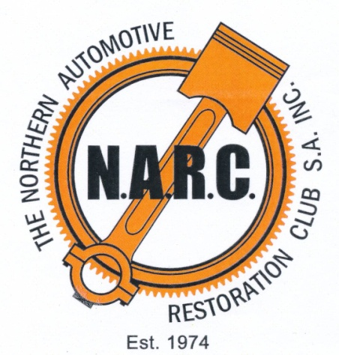
Conditional Registration

THE STEPS YOU NEED TO TAKE
- CHECK YOUR VEHICLE IS ELIGIBLE – all the criteria below must be met

- As of 1st July 2022, vehicles are eligible if 25 years or more have elapsed since 1 January of the year in which the vehicle was manufactured. This means:-
During 2022, vehicles manufactured before 31st December 1997 are eligible
During 2023, vehicles manufactured before 31st December 1998 are eligible etc. etc.

- Your vehicle as above must be able to be driven legally on a public road in its current configuration. More detail on this is available in the Code of Practice¹.

- Left hand drive vehicles must have a Certificate of Exemption from the South Australian Dept for Infrastructure and Transport. Note – any current certificate you may have for the vehicle is good for the purpose of Conditional Registration.

- Your vehicle must comply with NARC’s own policy – we are not a hot rod / street rod club, and will not admit vehicles where major performance modifications have been made. If in doubt, refer to the NARC Club Registration Policy².

- VEHICLES NOT PREVIOUSLY REGISTERED IN SOUTH AUSTRALIA

- Vehicles not previously registered in South Australia must be presented at a Police Station for an identity check to ensure it has not been stolen. To do this the police officer must be able to read both the engine number and the VIN/Chassis Number from above. If this is not possible, you will first have to take the vehicle to a registered motor mechanic and have him find the numbers and provide you with a letter of confirmation on his letterhead.
- If the vehicle is roadworthy, a temporary permit from a Services SA centre can be used to move the vehicle, otherwise it must be on a trailer.
- Any documentation you can provide – details of previous owner, interstate registration details, receipts etc. will assist this process. You will also need to provide your address and Driver’s License Number.

- OBTAIN AN MR334 FORM FROM THE CLUB
- Vehicle Inspectors authorised by the Department to issue MR334 forms on behalf of the Club are listed in Con-Rod – the Club magazine.
- Once you’ve identified the person in the area nearest you, please make contact to arrange a suitable time to meet and complete the paperwork. For this to happen you will need to provide the following:-
- Make , year, engine and VIN/Chassis numbers for the vehicle (vehicles made prior to 1989 don’t need to have the VIN/Chassis number but if you have one, so much the better). We may also require you to present the vehicle or a comprehensive set of photos to ensure the vehicle meets Club requirements.
- Registration plate number (if the vehicle has been or is already registered in SA)
- Your address details and Driver’s License Number.

- REGISTERING THE VEHICLE
If you’ve done all the above, this is the easy bit! Take your Vehicle Identity Inspection Report (if appropriate) and MR334 Form in to a Service SA Centre and register your vehicle.

Notes:-
- If the vehicle is left hand drive, you will also need to take the original certificate of exemption with you, and
- If you have bought a car registered in SA which has personalised plates and you wish to retain them, you will need to have a letter from the previous owner relinquishing his / her right to that number
- Numeric plates may or not be able to be transferred from one owner to another. It depends on the circumstances, so you will need to establish proof of your right to use a number (if it’s not already on the vehicle in your name and you are just converting from Full to Conditional registration.

- OBTAINING YOUR LOG BOOK
Once the vehicle is registered, send your new registration papers (scan and email, photograph and text or photocopy and post) to the Club’s log book controller who will provide you with your log book and a few instructions as to what you need to do from then on to enable you to legally use your vehicle.
This person is currently:
Graham Burgess
31 Kingston Rd. Port Pirie SA 5540
Ph 0407 793 876
Email gramarb@internode.on.net

- CHANGING NUMBER PLATES
If at any time after registering your vehicle you wish to change the number (ie. if you have a ‘standard’ alpha-numeric plate and want to change to a personalised one), please advise Graham Burgess, and make the appropriate alteration in your log book.

References:
- https://www.sa.gov.au/topics/driving-and-transport/registration/conditional-registration/historic-left-hand-drive-and-street-rod-vehicles
- Narc.org.au. Go to DOWNLOADS – NARC conditional rego policy

NOTE:- Neither the Police Vehicle Identity Inspection or the Club Inspection form an assessment of roadworthiness. That is entirely up to you.

